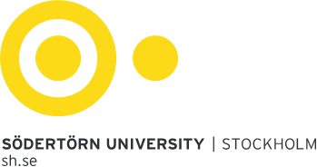

Alfred Nobels allé 7, Flemingsberg • 141 89 Huddinge • 46 08 608 40 00 • Org nr 202100–4896 • info@sh.se

[Fyll i kursens namn på engelska, antal credits]
(Fyll i kursens namn på svenska, antal högskolepoäng)

Course code | [Fyll i här]
Discipline for doctoral studies | [Fyll i här]
Academic school | [Fyll i här]
Research area for doctoral studies | [Fyll i här]
Grading scale | G
Education cycle | Doctoral studentship
Language of instruction | [Fyll i här]
Valid from | [Fyll i här]

Validation
This course syllabus was validated by the Committee for Research and Doctoral Education at Södertörn University on XXXX according to the stipulations in the Higher Education Ordinance

Entry requirements
Admitted to doctoral studentship

Learning outcomes
After completing the course, the doctoral student is able to:
[Fyll i här]

Course content, modules and examinations
[Fyll i här]

Course design
[Fyll i här]

Examination format
[Fyll i här]
The grading criteria are distributed prior to the start of a course or module.
If a student has a certificate from Södertörn University for compensatory support, the examiner has the right to decide on an adapted examination or alternative form of examination in accordance with Södertörn University's regulations.

Restrictions on accreditation
The course may not be accredited as part of a degree if the contents are partly or wholly the same as a course previously taken in Sweden or elsewhere.

